**User Manual Layout Screen Pages:**

INDEX:

Main Menu Screen 2

Options Menu Screen 3

Game Screen 4

Restart Screen 5

Main Menu Screen

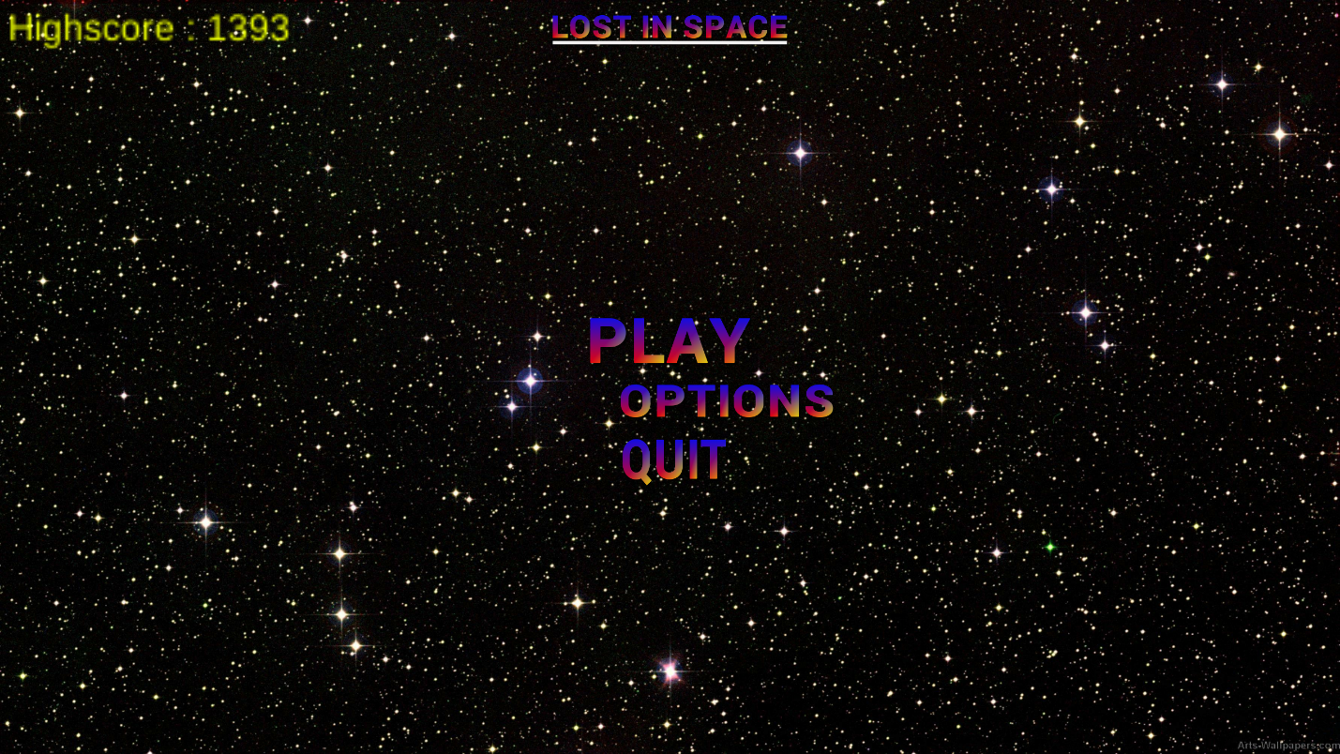

Options Menu Screen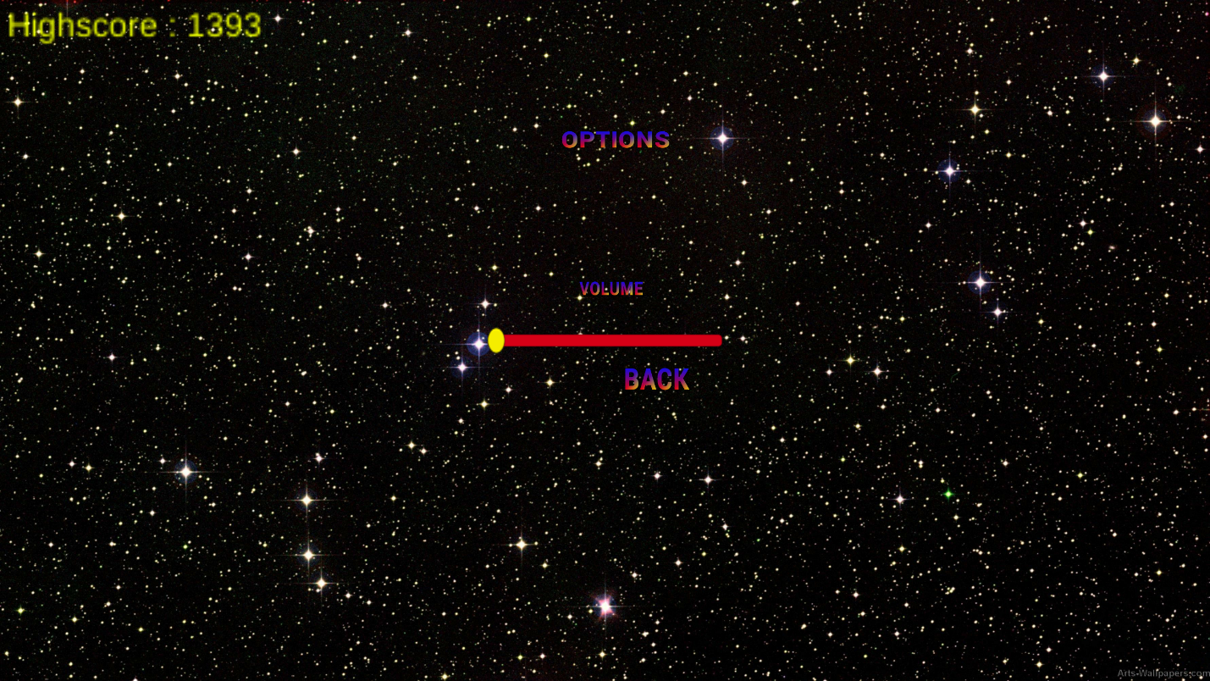

Game Screen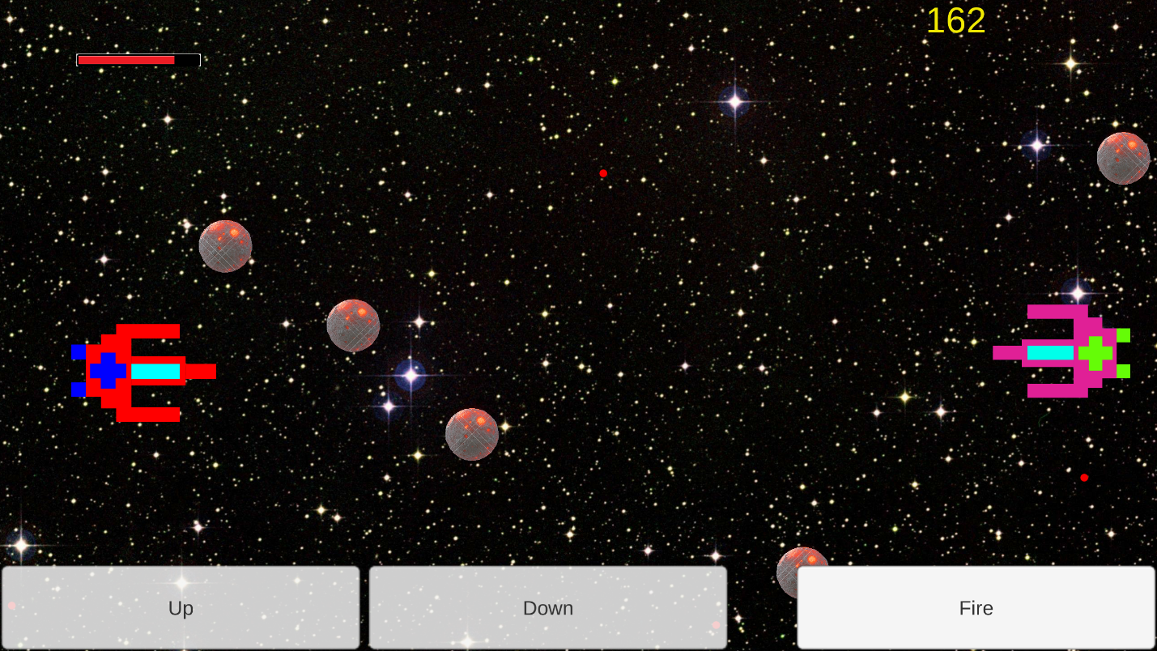

Restart Screen

